Holy Redeemer Catholic Church
1227 East Bristol Road Burton, Michigan 48529
Sponsorship Opportunities at Holy Redeemer Church

Saturday, October 14th ,2023
Dinner & Silent Auction
5pm – 9pm
Holy Redeemer Family Life Center

Dinner
Silent Auction
50/50
Lucky Ticket Raffle

We invite you to support Holy Redeemer’s fundraiser through a sponsorship or donation. Holy Redeemer offers many ministries for the community including Outreach, Community Lunch, Youth Group, Children’s Ministry, Vacation Bible School and more!
Becoming a sponsor helps support these ministries and provides you an
opportunity to advertise your business.

We are planning a fundraiser this year October 14th,2023
If we raise enough funds, we will be adding much needed air conditioning to the Ministry Center, which we use for many parish gatherings and community functions.

Please consider becoming a sponsor or donating items.
All support is greatly appreciated!

Please contact Beth Clark by calling 810-244-1692
or email Bethclark522@gmail.com, if you have any questions.

Holy Redeemer Catholic Church
1227 East Bristol Road Burton, Michigan 48529

Sponsorship – Donation form
Sponsorship Participation Level (please check your selection)
GOLD SPONSOR  $2000.00  - Booth space available  - Logo Recognition  on all Event Promotions  - Bulletin Advertisement  for 1 year  - You will receive 4 dinner passes for  this event. | SILVER SPONSOR  $1000.00  - Booth space available  - Logo Recognition  on all Event Promotions  - You will receive 2 dinner passes for  this event | BRONZE SPONSOR  $500.00  - Logo Recognition  - on all Event Promotions | ANY DONATION  ________________  ________________  Money,  Gift Cards or  Gift Certificates,  Prize Items, etc.

ALL Business Names will be listed on the Website, Social Media, and Church Bulletin.
Money or Gift Cards will help us to buy the many needed supplies, food, pop, paper products as well as prize items for Tootsie Roll Booth, Kids Games, and Lucky Ticket Raffle. Thank you for your generosity!
Business Name:
Address:
Phone : ____________________________Email :____________________________________

Please send the following with this form no later than September 16th , 2023
- Business card or email a High Resolution company logo, to bethclark522@gmail.com
- Make checks payable to Holy Redeemer Church.
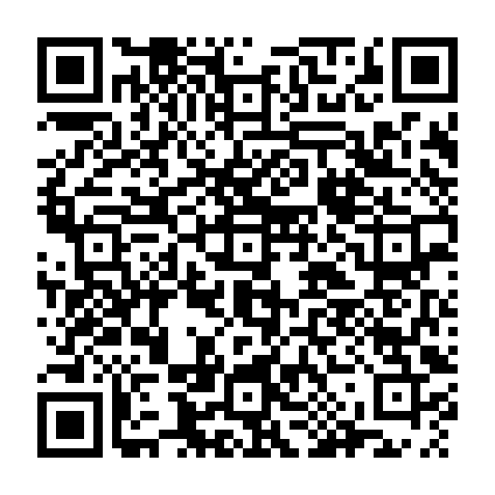
Mail to: Holy Redeemer Church - Fundraiser,1227 E. Bristol Rd., Burton, MI 48529
Or you can pay online @ http://www.holyredeemerburton.org/online-giving ... Or scan
Under Fund drop down pick special offering / memo sponsor/ donation
Your signature below authorizes Holy Redeemer to reproduce the logo for promotional purposes for the
Holy Redeemer Fundraiser.

Date: _______________

Print:

Signature: __________________________________________________________________________

